**Topics: Descriptive Statistics and Probability**

* Look at the data given below. Plot the data, find the outliers and find out

|  |  |
| --- | --- |
| **Name of company** | **Measure X** |
| Allied Signal | 24.23% |
| Bankers Trust | 25.53% |
| General Mills | 25.41% |
| ITT Industries | 24.14% |
| J.P.Morgan & Co. | 29.62% |
| Lehman Brothers | 28.25% |
| Marriott | 25.81% |
| MCI | 24.39% |
| Merrill Lynch | 40.26% |
| Microsoft | 32.95% |
| Morgan Stanley | 91.36% |
| Sun Microsystems | 25.99% |
| Travelers | 39.42% |
| US Airways | 26.71% |
| Warner-Lambert | 35.00% |

**Answer** : Mean- 0.3327

Std. Deviation- 0.1694

Variance- 0.2871

Morgan Stanley is an outlier of 91.36%

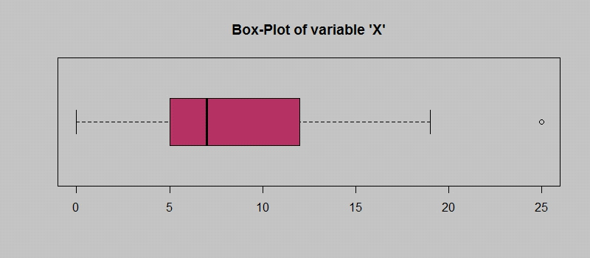

**Answer the following three questions based on the box-plot above.**

* What is inter-quartile range of this dataset? (please approximate the numbers) In one line, explain what this value implies.

**Answer** : IQR=12-5=7,this represent the range which contains 50% of the data points.

* What can we say about the skewness of this dataset?

**Answer :** Dataset is right skewed(positively)

* If it was found that the data point with the value 25 is actually 2.5, how would the new box-plot be affected?

**Answer:** 2.5 will not be consedered an outlier, The boxplot starts from 0 and send at 20 in

represention

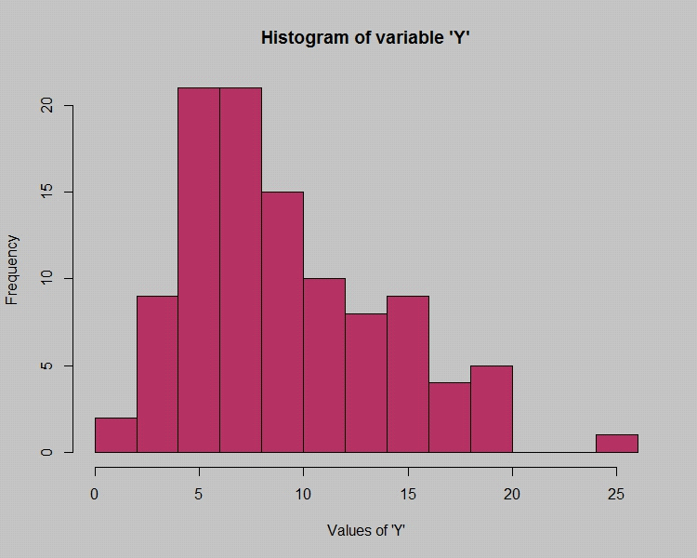

Answer the following three questions based on the histogram above.

* Where would the mode of this dataset lie?

**Answer :** Mode is lies between 4 and 8

* Comment on the skewness of the dataset.

**Answer** : Dataset is right skewed

* Suppose that the above histogram and the box-plot in question 2 are plotted for the same dataset. Explain how these graphs complement each other in providing information about any dataset.

**Answer :** Mode is in Histogram,Histogram provides the frequency distribution so we can see

how many times each datapoint is occurring,However boxplot provide the quantile

distribution i.e,50% data lies between 5 and 12.Boxplot is providing whisker length to

find at outliers. No information is getting from histogram.We can assume the outliers

at the gap 25 may be an outlier.

* AT&T was running commercials in 1990 aimed at luring back customers who had switched to one of the other long-distance phone service providers. One such commercial shows a businessman trying to reach Phoenix and mistakenly getting Fiji, where a half-naked native on a beach responds incomprehensibly in Polynesian. When asked about this advertisement, AT&T admitted that the portrayed incident did not actually take place but added that this was an enactment of something that “could happen.” Suppose that one in 200 long-distance telephone calls is misdirected. What is the probability that at least one in five attempted telephone calls reaches the wrong number? (Assume independence of attempts.)

**Answer :** one in 200 long-distance telephone calls is misdirected

=)Probability of calls misdirecting p=1/200

Probability of call not missdirecting=1-1/200= 199/200

Number of calls =5

P(x)= ⁿCₓpˣqⁿ⁻ˣ

n=5

p=1/200

q=199/200

At least one in five attempted telephone calls reaches the wrong number

=1- none of the car reaches the wrong number

=1-P(0)

=0.02475

Probability that one in five attempted telephone calls reaches the wrong number

=0.02475

* Returns on a certain business venture, to the nearest $1,000, are known to follow the following probability distribution

|  |  |
| --- | --- |
| x | P(x) |
| -2,000 | 0.1 |
| -1,000 | 0.1 |
| 0 | 0.2 |
| 1000 | 0.2 |
| 2000 | 0.3 |
| 3000 | 0.1 |

* What is the most likely monetary outcome of the business venture?

**Answer :** As the probability 0.3 is more for 2000$ as compared to others, hence most likely

monetary outcome of the business venture 2000$.

* Is the venture likely to be successful? Explain

**Answer** : long-term average=(-2000*0.1)+(1000*0.1)+(0*0.2)+(1000*0.2)+(2000*0.3)+(3000*0.1)

=800$

As the lon-term average gives positive numbers the business venture likely to be

successful.

* What is the long-term average earning of business ventures of this kind? Explain

**Answe**r **:** long-term average =800$

Means on an average return will be 800$

* What is the good measure of the risk involved in a venture of this kind? Compute this measure

Answer : Risk involved in a venture

Var(x)=2160000(Quite high)

SD = $1470

As variability is quite high, hence risk is high